A000-Asia-Palm Leaf MS-ca. 1800

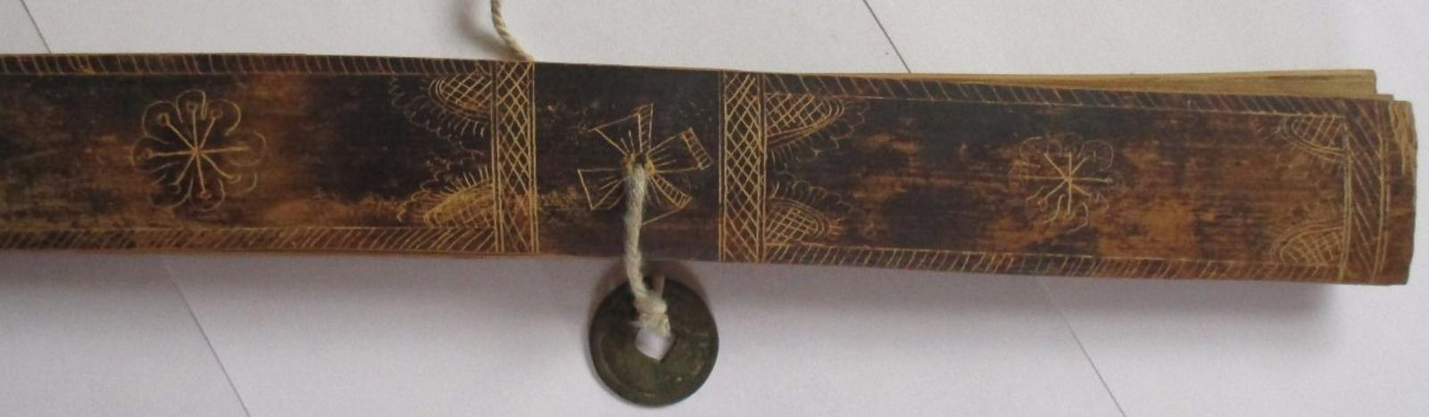

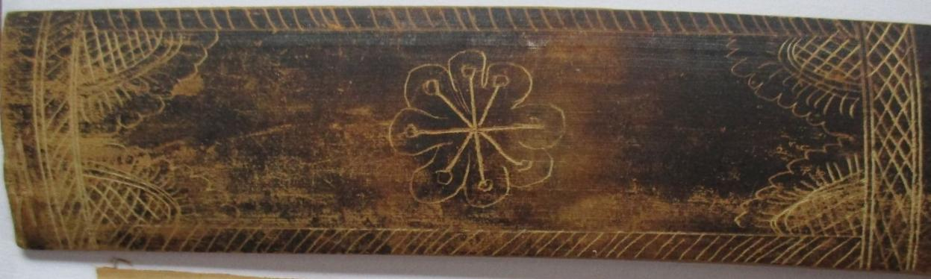

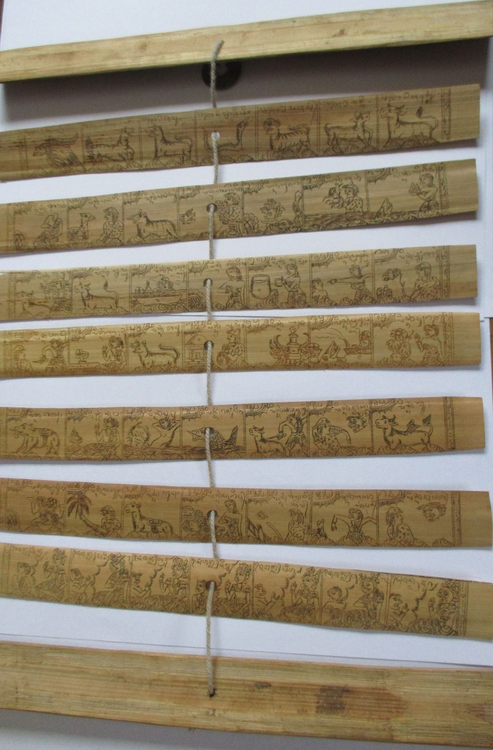

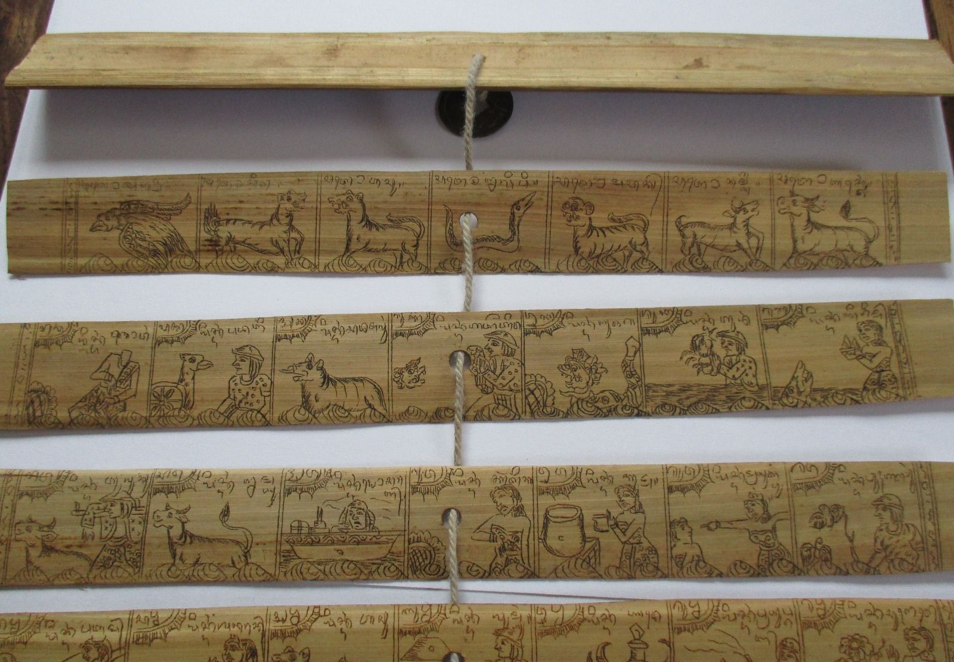

Case No.: 3

This 7 palm-leaf manuscript (11 in. x 1.25 in. relates a story together with illustrations on one side only.  The other side is blank.  There is some significant wear of the finish on the outside covers. The palm leaves are in very good condition and a few have creasing,/cracking or chipping.  The string holding the manuscript together is secured with a coin on one side and a knot (probably missing its other coin) on the other.  The date of the coin suggests its probable age.